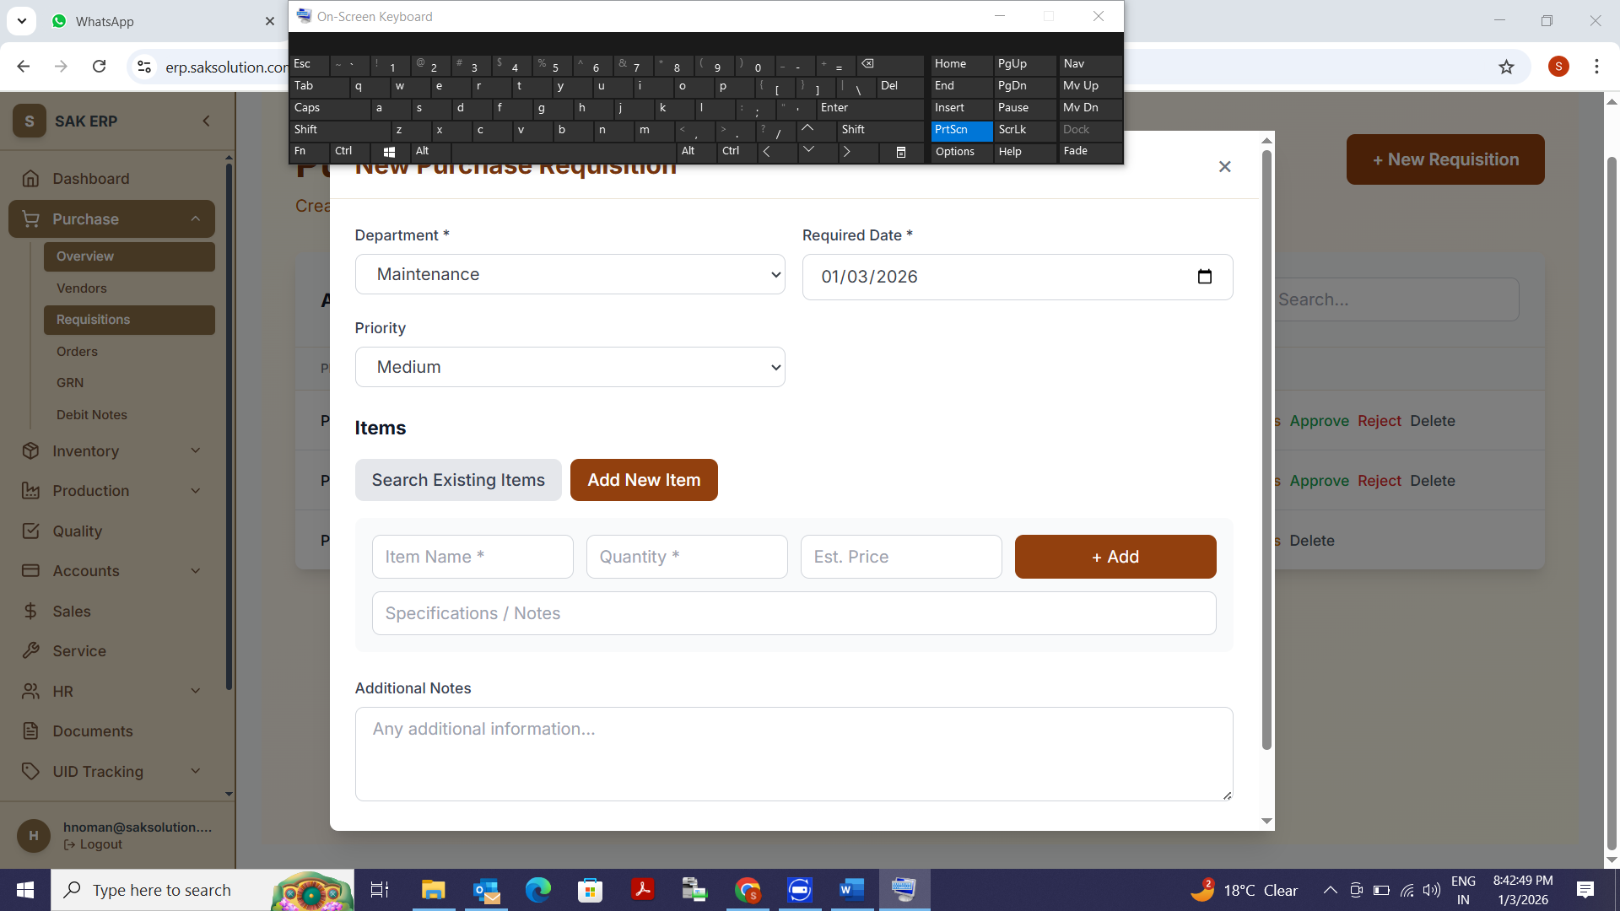
Add Item Button not responding
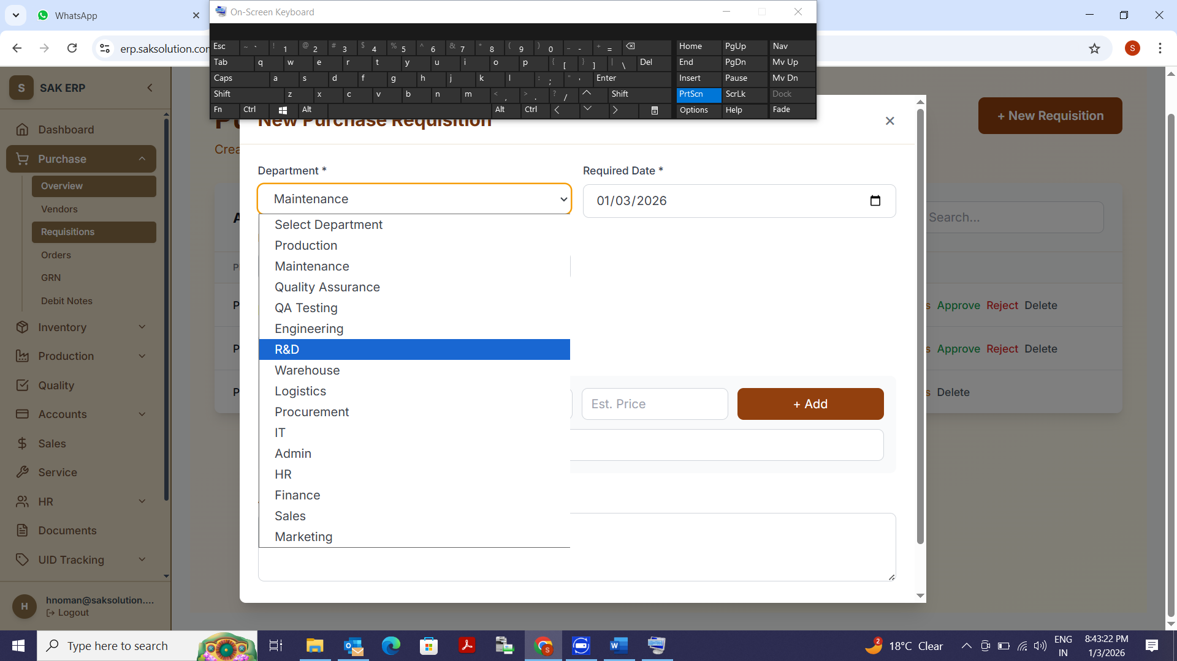
What is significance of this Department, Where is the detail captured and how is it processed.

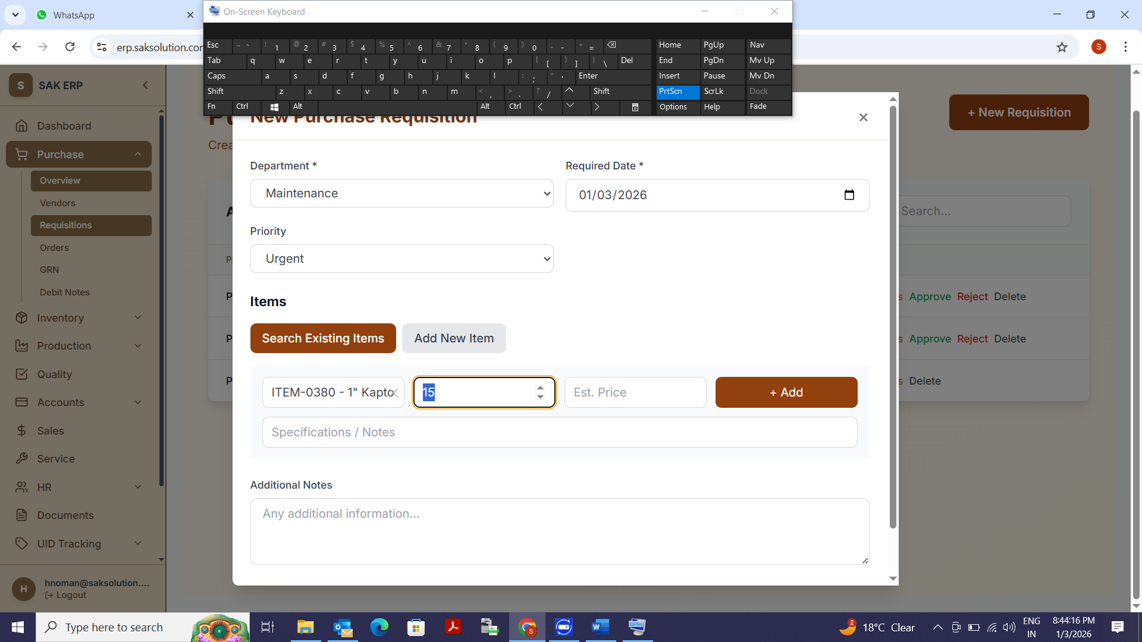
Along with Qty, the Unit of the Part List should come.
What is the significance of Ext Price?
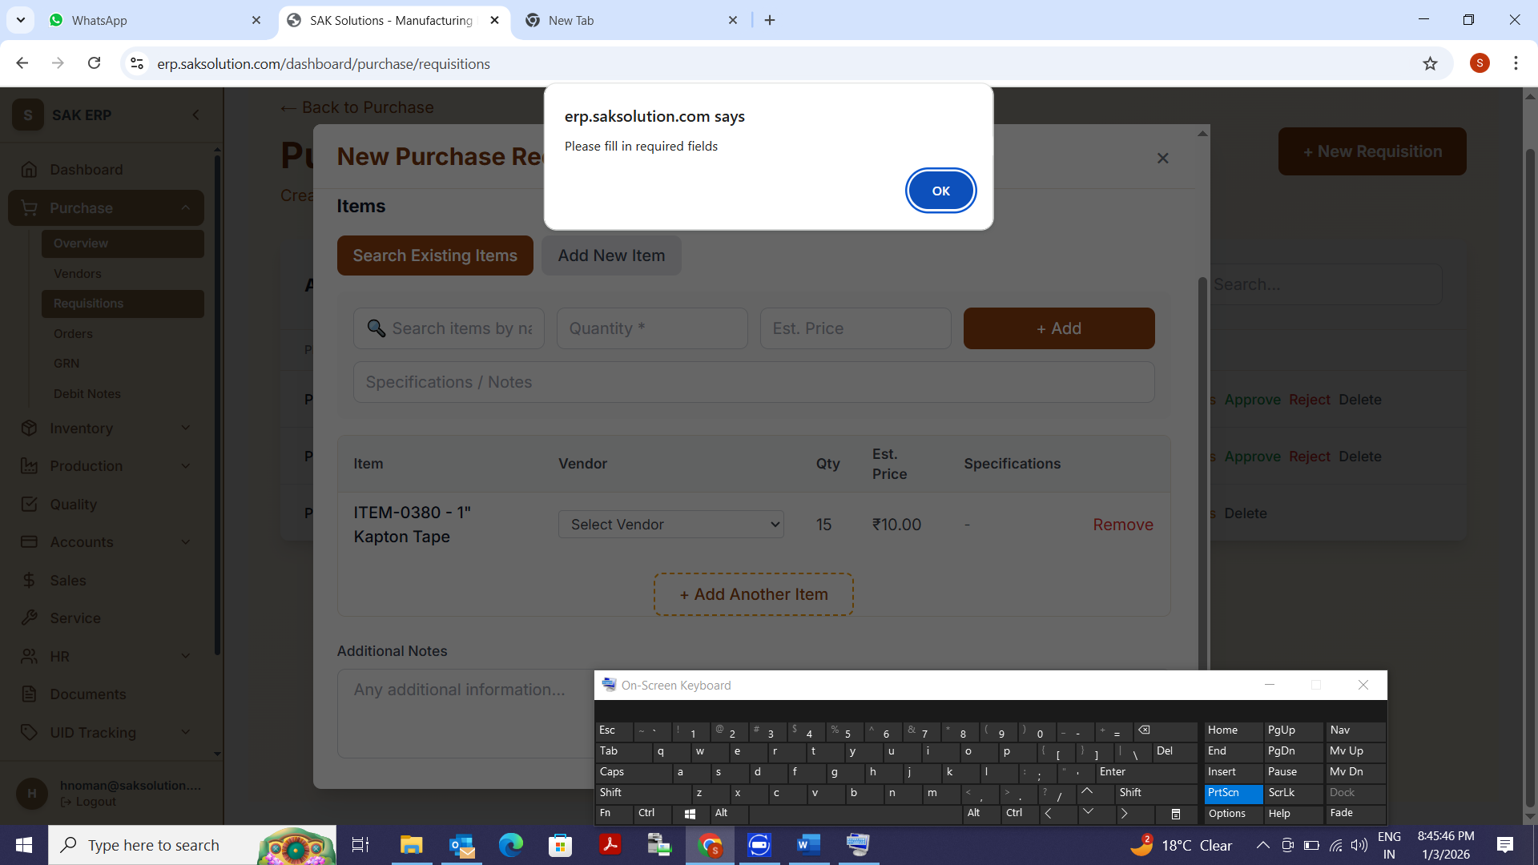
When clicking on Add Items, this pop up is coming

Selection of Vendor at PR Level, is that required.

Edit option not available. We can have at Line level and also on complete PR Level
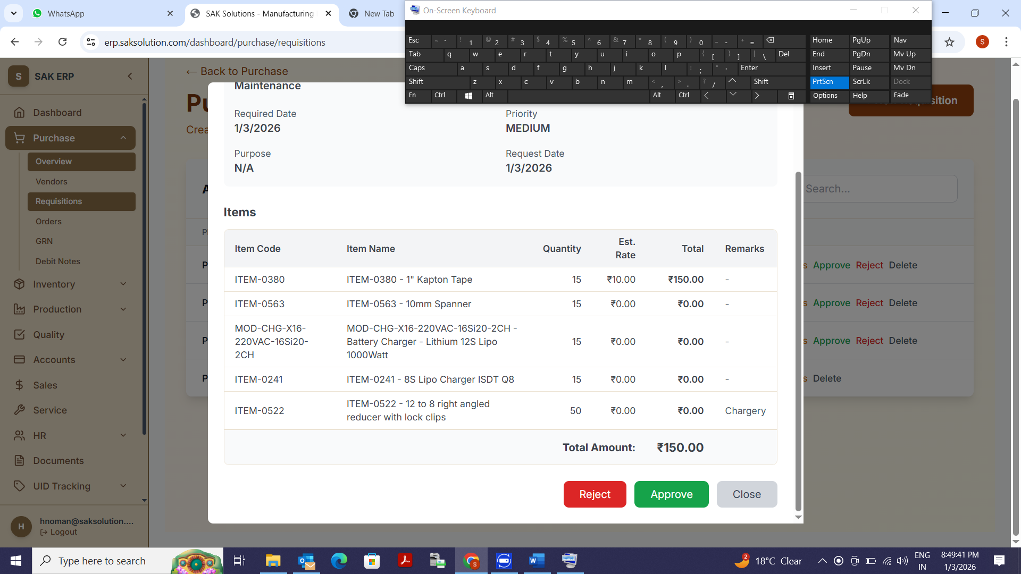
At approval level also edit option should be there. Here we are getting only Approve and Reject Option
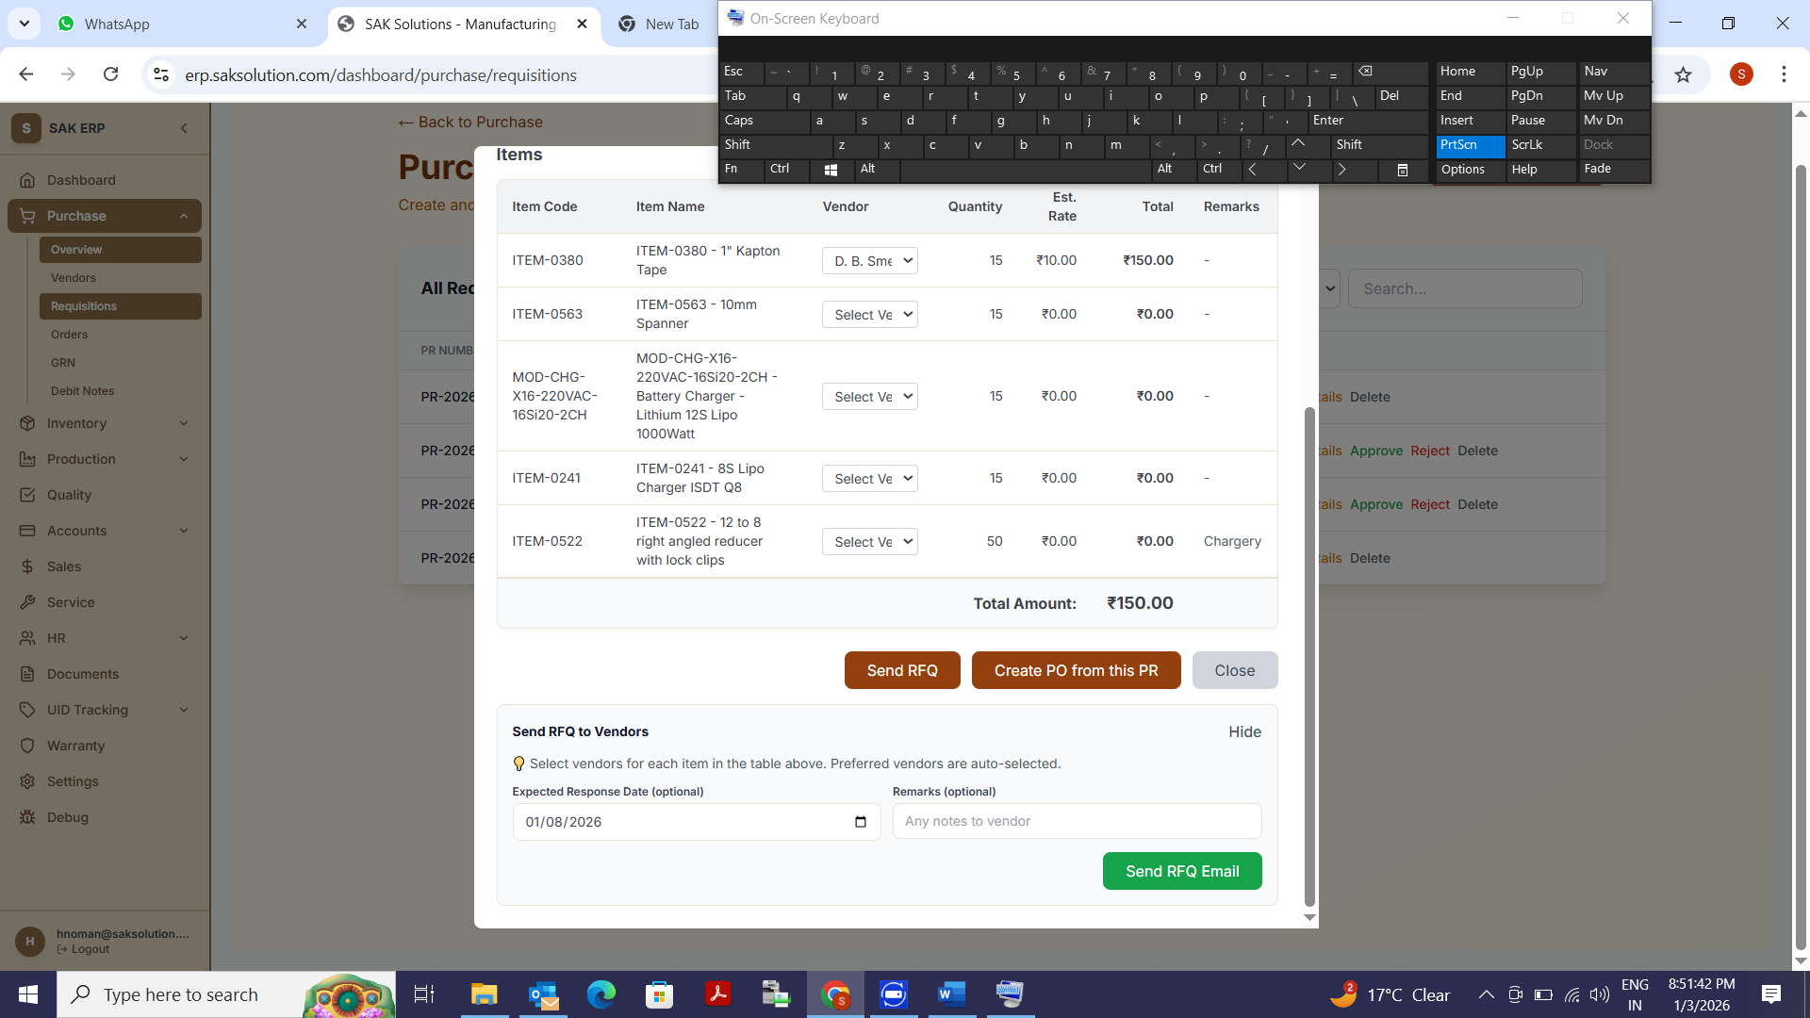
Email Option for RFQ, The items against which preferred vendors Tag, there names comes automatically, and then option of Sending to multiple vendors for each line items.
The Preview of Mail which will go should be available before sending.
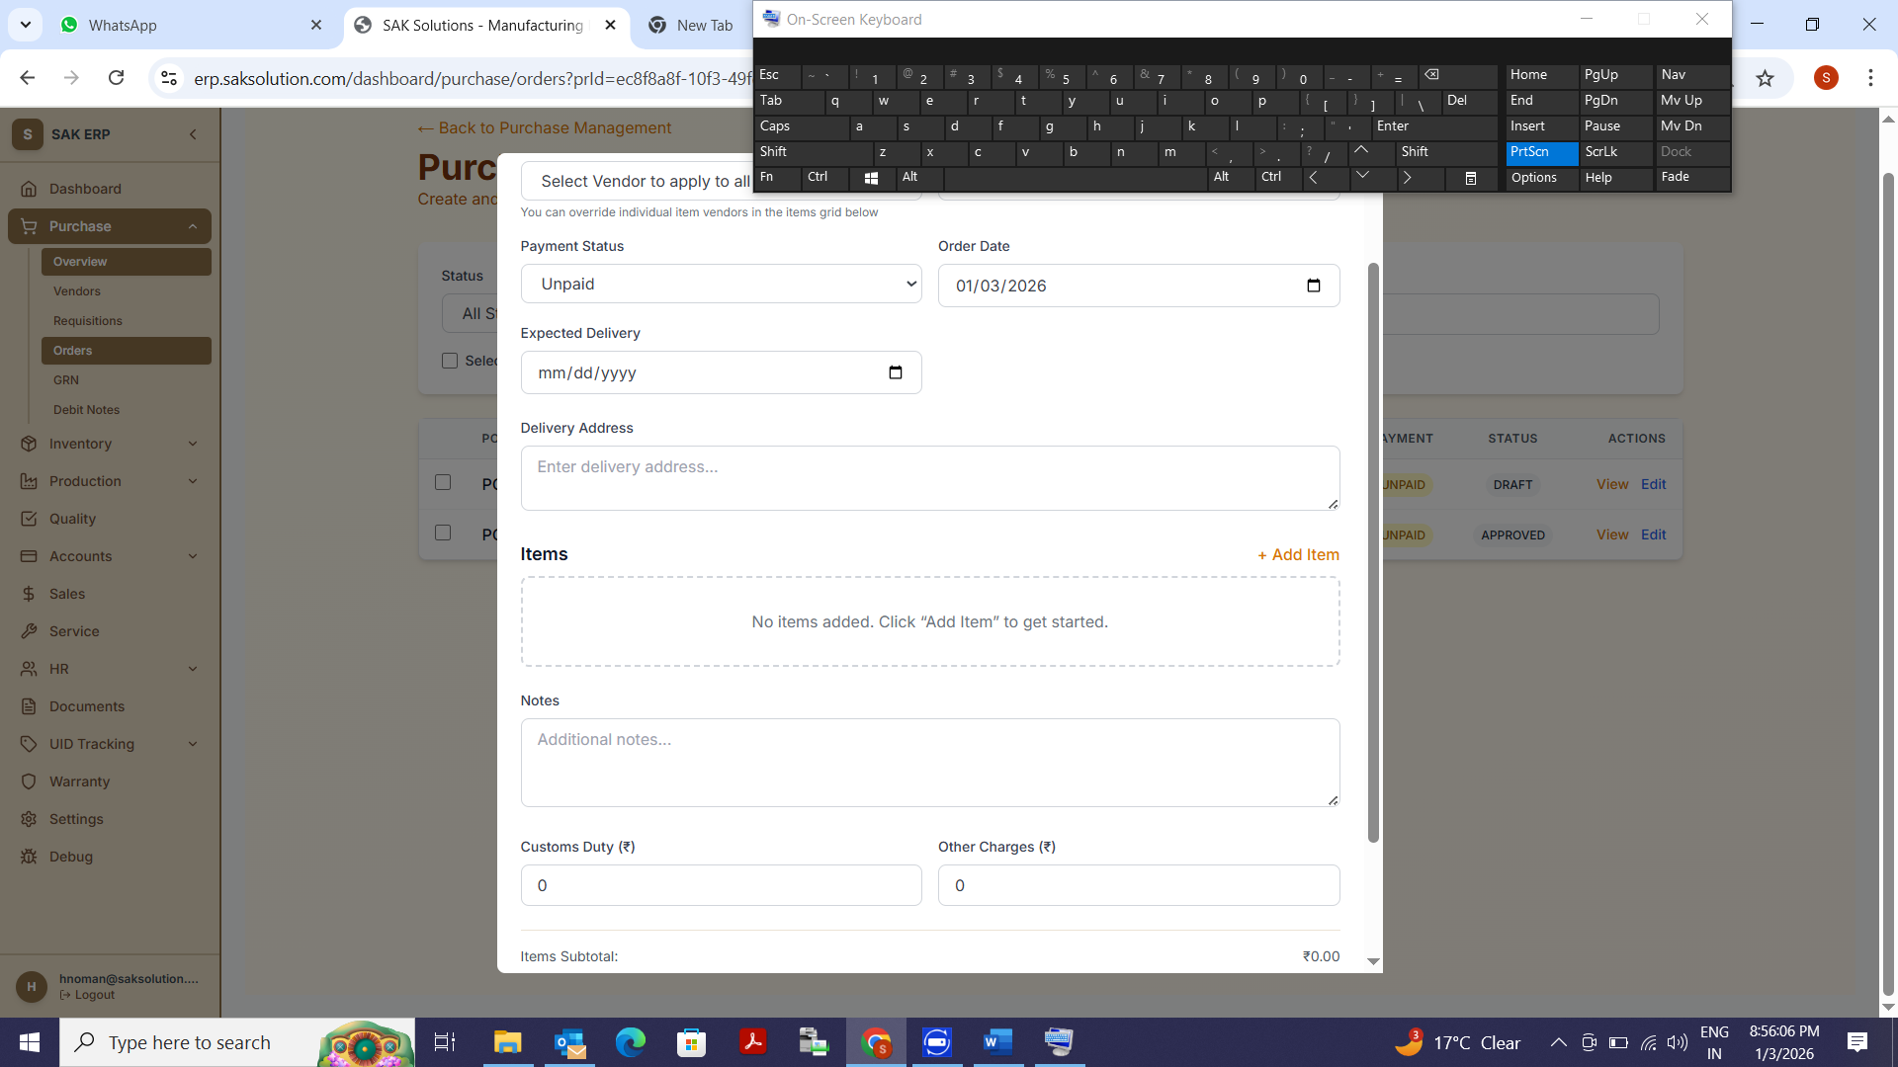
When creating PO, we should have the option of selecting the PR, and In case in PR some any of the line items against which PO is generated, then it will not be shown during creating of PO.
Each Line item of the PR may have different Commercial Terms like, Payment, Delivery etc
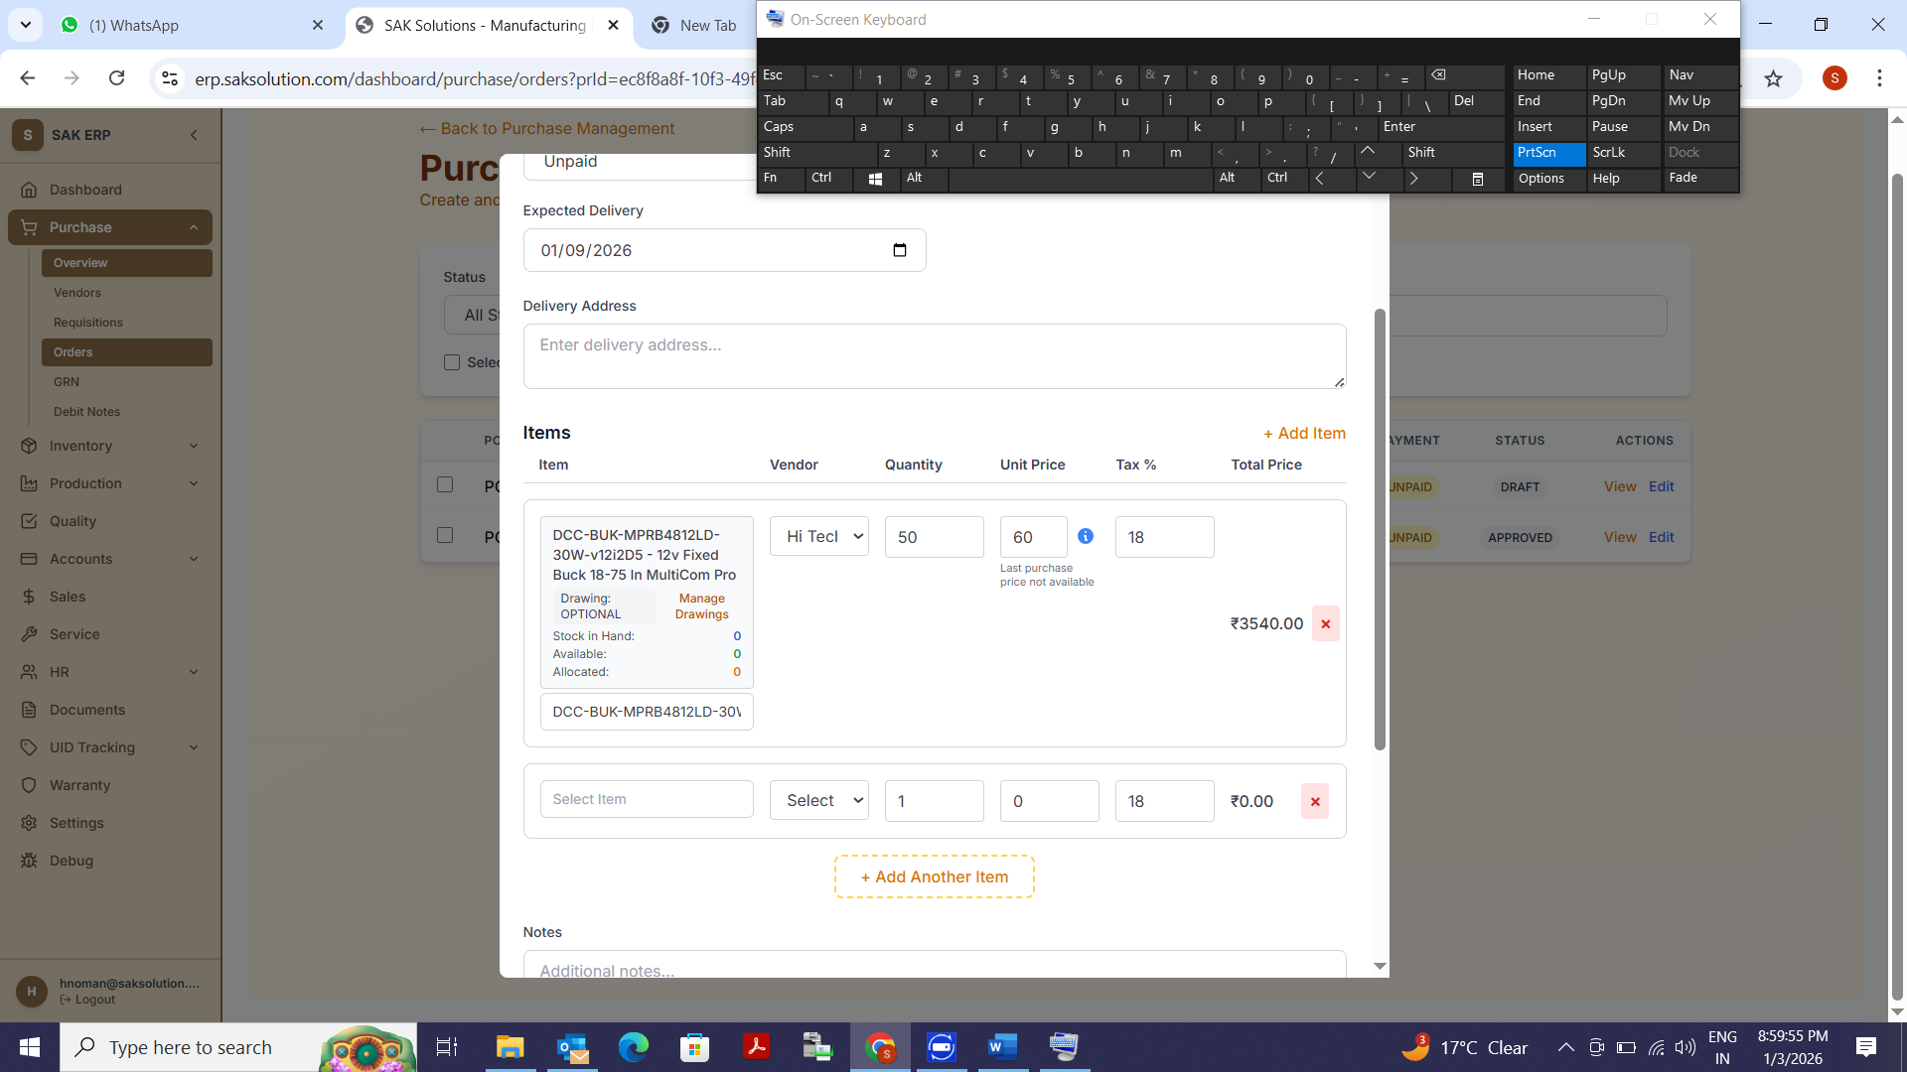
Qty and Unit of the Qty to be indicated here
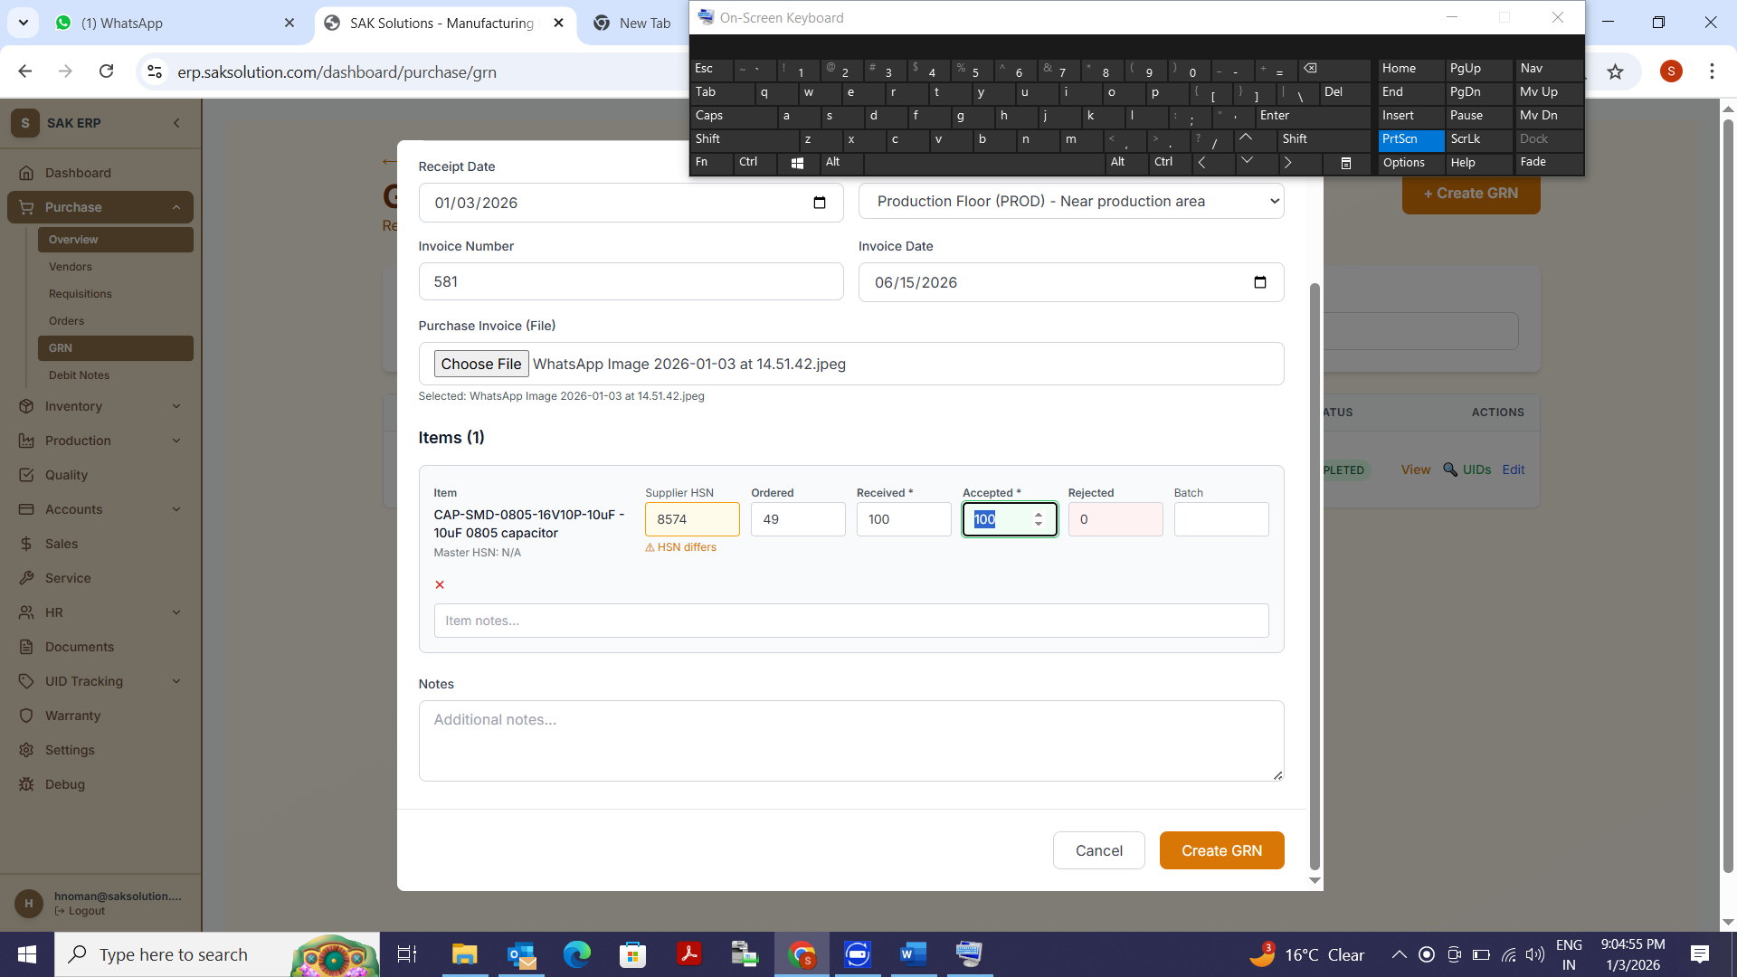
GRN Received cannot be more than Ordered Items. Restriction to be there.
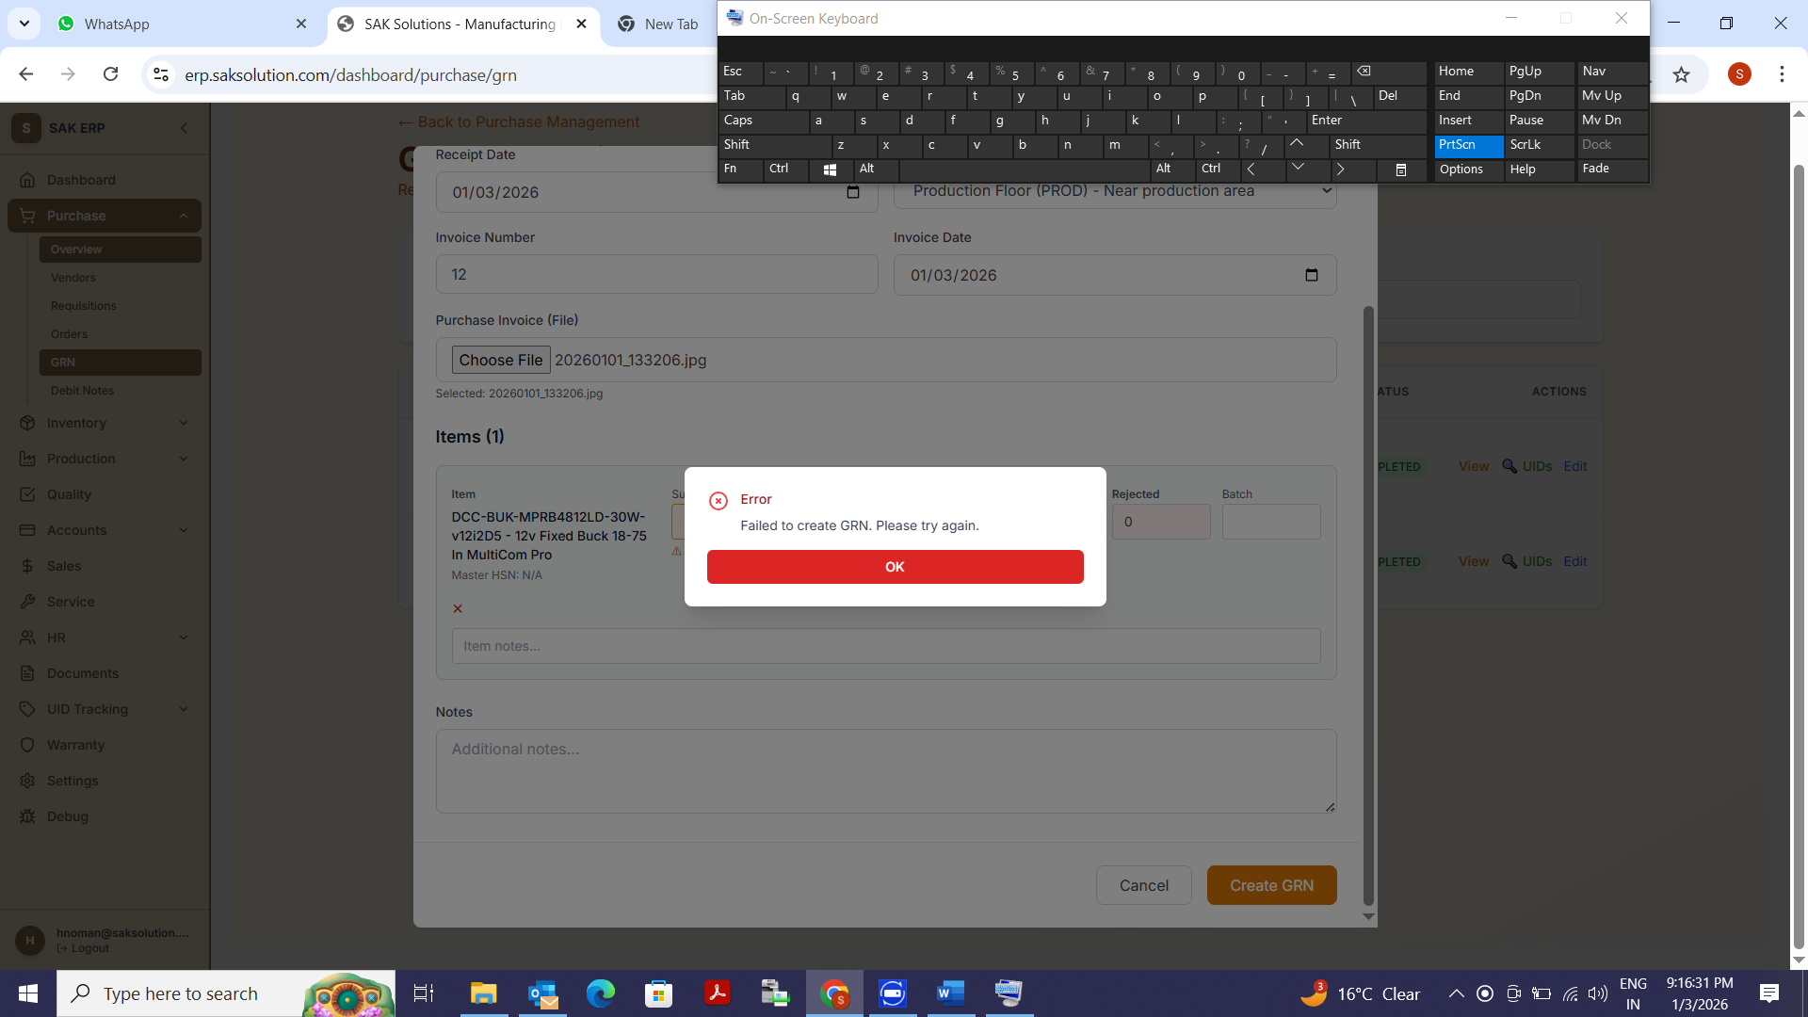
This is the error sign coming
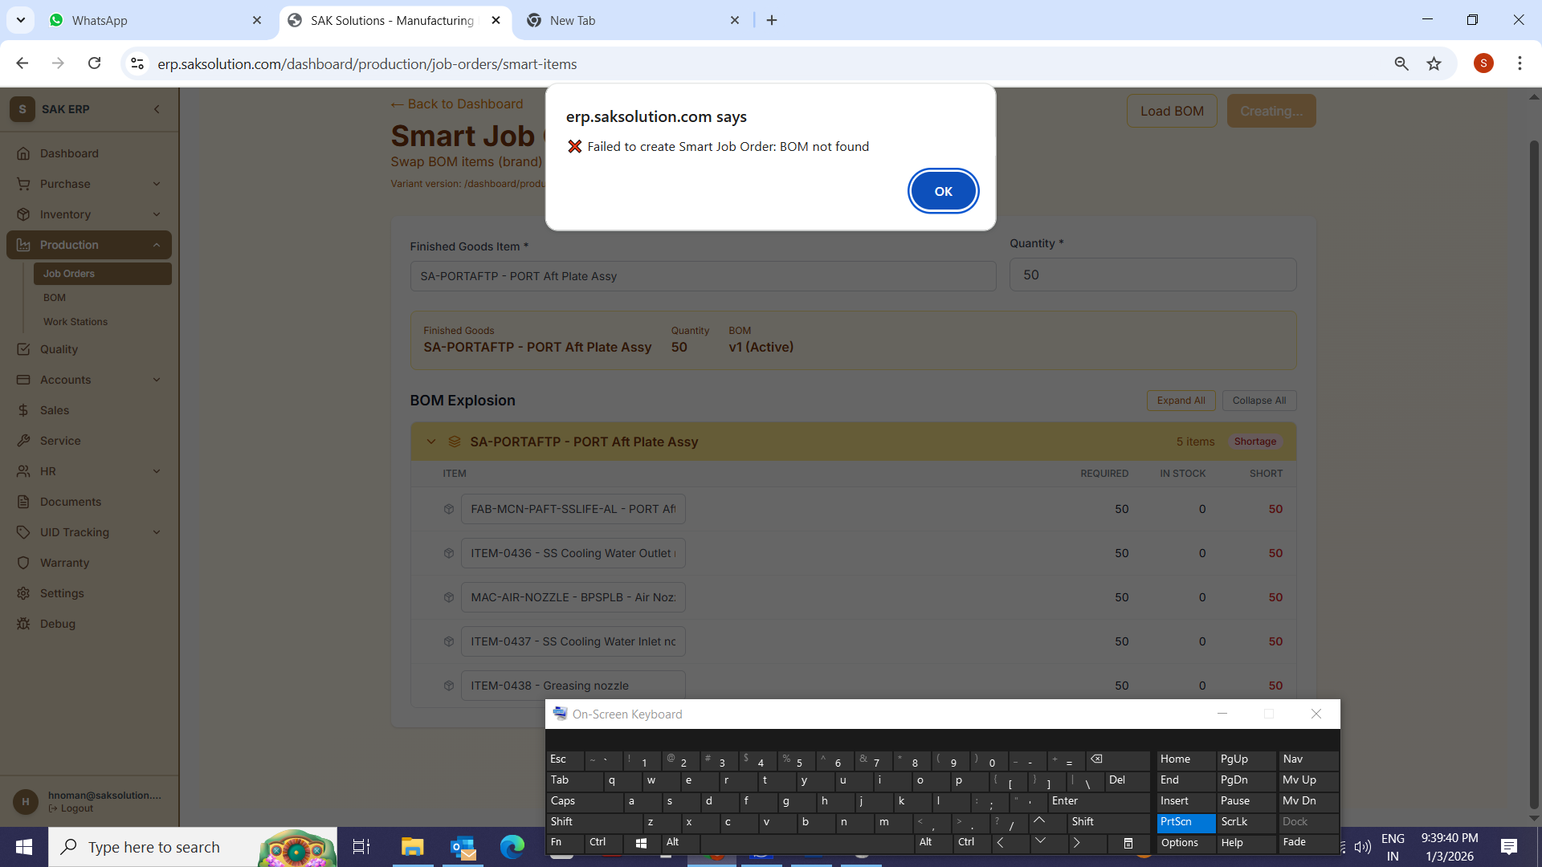
Check this Error
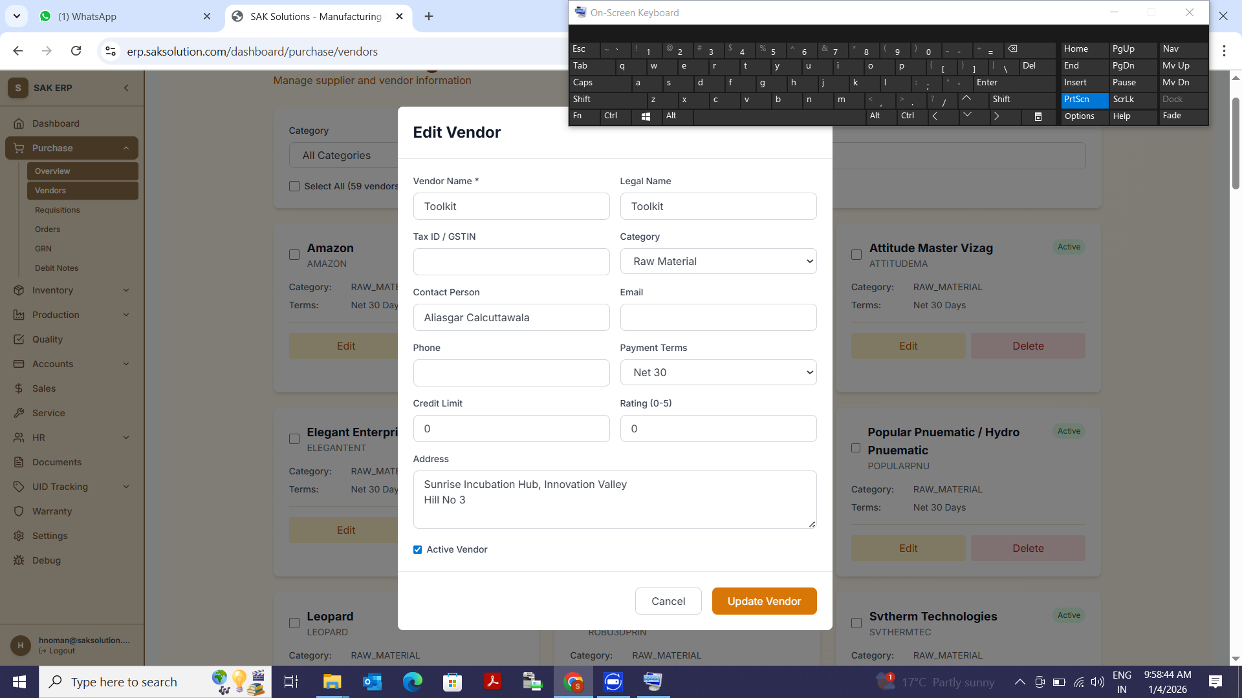
Proper Address Format needed

